Gradient Descent + scikit-learn for Logistic Regression
Short name: LogReg_GD_Sklearn · Combined Coursera C1_W3 Lab06 (GD) and Lab07 (sklearn)

Problem Statement
Lab06 asks you to write the logistic gradient and run batch GD on a six-point, two-feature set (plus a one-feature tumor-size set). Lab07 fits the same six points with sklearn LogisticRegression. Gaps: default sklearn is L2, so coefficients will not match unregularized GD even at 100% train accuracy; there is no editable simulation of α / m / noise; there is no audience layer. This pack merges the labs and fills those gaps.

Solution Strategy
- Implement a clipped sigmoid, loop cost, loop gradient (Lab06 equations 2–3), then a vectorized Xᵀ(f−y)/m alternate.
- Run batch GD from w=0, b=0 with α=0.1 for 10,000 steps; store J; draw the P(y=1)=0.5 contour.
- Fit sklearn twice: C=np.inf (unregularized) and default C=1 (L2). Overlay the three boundaries.
- Reuse the same code on a 40-point practice set and a 1-D DTI→default drill.
- Monte-Carlo: vary α and m with 5% label flips. Rewrite results for four reader types (Jočys + McMurrey).

Solution
Gradient check matches the lab: dj_db ≈ 0.498618, dj_dw ≈ [0.498333, 0.498839] at w=(2,3), b=1. After 10k steps, w ≈ (5.281, 5.078), b ≈ −14.222, J ≈ 0.017, train acc = 1.0. 1-D tumor 0.5-threshold ≈ 2.46. sklearn C=∞ also scores 1.0 at larger |w|; default L2 shrinks |w| to ≈ (0.90, 0.74) and still scores 1.0 — coefficient equality is the wrong unit test on six points.
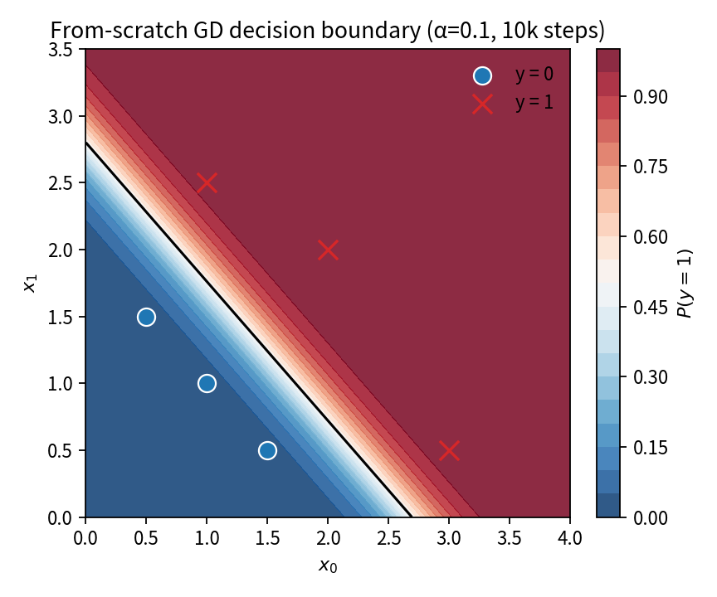  GD field + 0.5 contour | 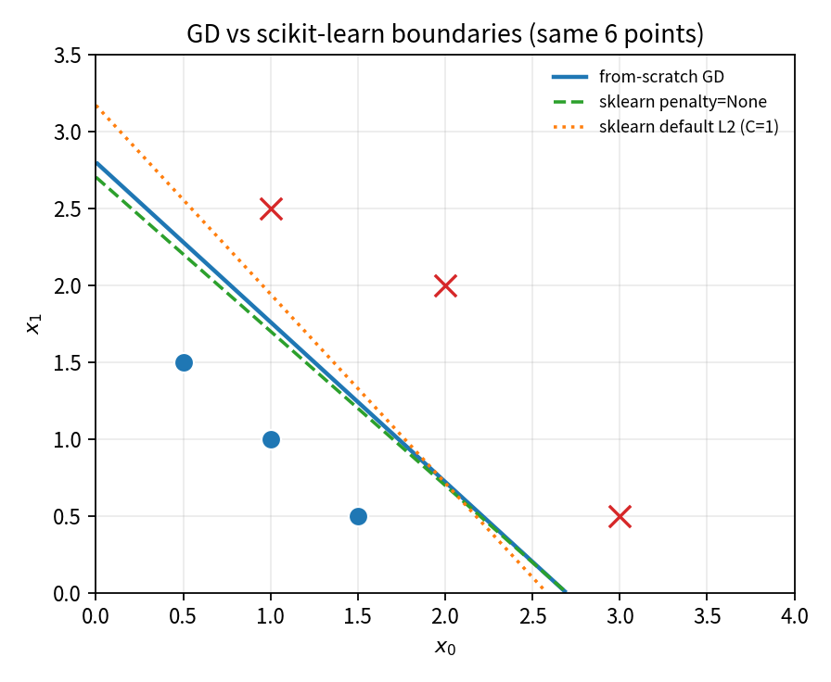  GD vs C=∞ vs default L2

Key Takeaways
- Logistic GD reuses the linear-regression gradient shape (f−y)x; only f is now a sigmoid.
- Clip z before exp and f before log. If J rises, cut α.
- sklearn’s default is not unregularized GD. Compare accuracy and the boundary, not raw w on tiny n.
- Threshold, α, C, and m are the knobs the simulation is built to expose.
- Same numbers, four voices: formulas for practitioners, PD/cutoff for analysts, headlines + L2 caveat for executives, “nudged dividing line” for non-specialists.

